EXPERIMENT 1

Aim
Simulation of Various Networking Topologies

Prerequisite
Nil

Outcome
To impart knowledge of Computer Networking Technology

Theory
Networking topologies refer to the arrangement of devices and their interconnections in a computer network. Different topologies offer unique advantages and drawbacks, influencing network performance, scalability, and fault tolerance. The choice of topology depends on specific requirements and use cases. Here is a brief overview of some common networking topologies:
- Bus Topology: In a bus topology, all devices are connected to a central communication medium, typically a single cable or “bus.” Devices share the same communication channel, and data is broadcast to all nodes on the bus. It is easy to implement and cost-effective for small networks, but it is susceptible to collisions, and a main bus failure can bring down the entire network.
- Star Topology: In a star topology, all devices are connected to a central hub or switch. The hub manages communication between devices, making installation and troubleshooting simple. A failure in one connection usually does not affect the entire network, but dependence on the central hub can be a single point of failure.
- Ring Topology: In a ring topology, devices are connected in a closed loop, where each device is connected to exactly two other devices. Data travels in one direction along the ring until it reaches the intended recipient. While simple and suitable for small networks, a failure in one node or connection can disrupt the entire network.
- Mesh Topology: In a mesh topology, each device is directly connected to every other device, ensuring redundancy and fault tolerance. This topology offers high reliability due to multiple paths for data transmission. However, it is complex and expensive, as the number of connections increases significantly with the number of devices.
- Hybrid Topology: A hybrid topology combines two or more different topologies, offering flexibility and optimization for network performance. It is suitable for tailoring networks to specific needs but can be complex to manage.
Procedure
- Open Cisco Packet Tracer and simulate the topologies of required size.
- Assign the IP Addresses to the system.
- Check the connectivity between the devices.
Steps
- Open Cisco Packet Tracer software.
- Build the topologies within Cisco Packet Tracer's workspace.
- Add devices from the device list (computers, switches) and place them on the workspace.
- Connect devices using appropriate cables (Ethernet cables or fiber optic cables).
- Assign IP addresses and subnet masks to each device to enable communication within the same subnet.
- Use the Ping tool located in the "Desktop" section of each device's configuration window.
- Note the ease of setup, fault tolerance, scalability, and any limitations specific to each topology.
- Utilize the simulation feature in Cisco Packet Tracer to simulate various scenarios.

Output
- Bus Topology
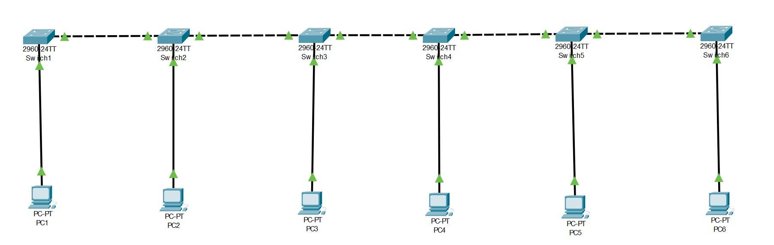
- Star
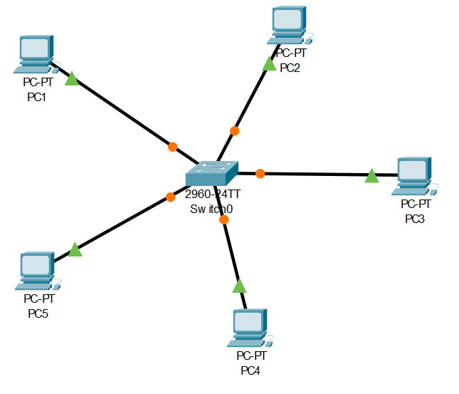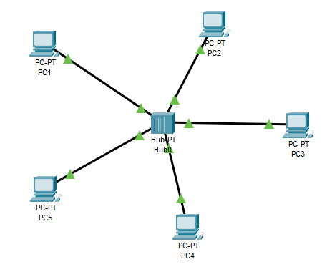
Fig 1: Using Switch Fig 2: Using Hub

- Ring
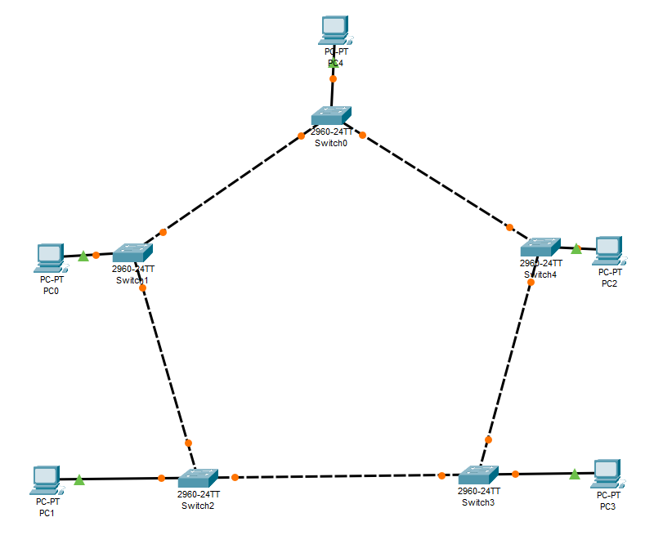

- Mesh
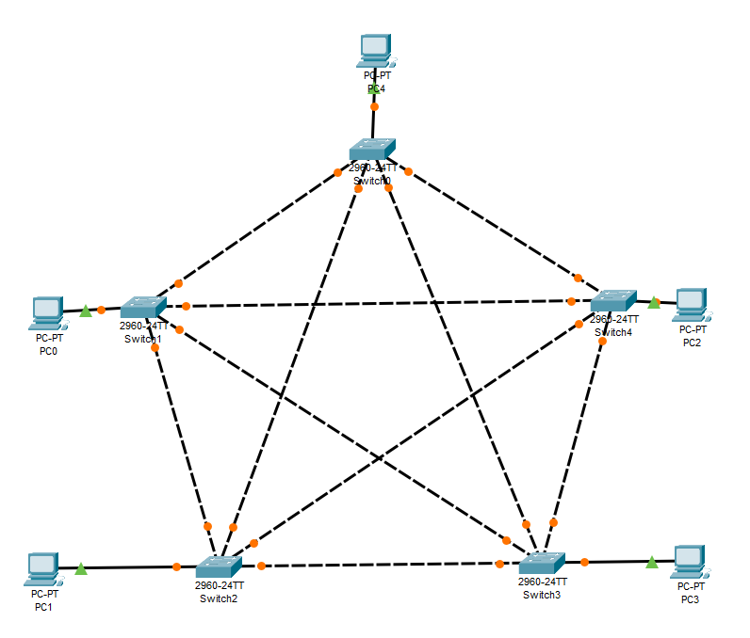
- Hybrid
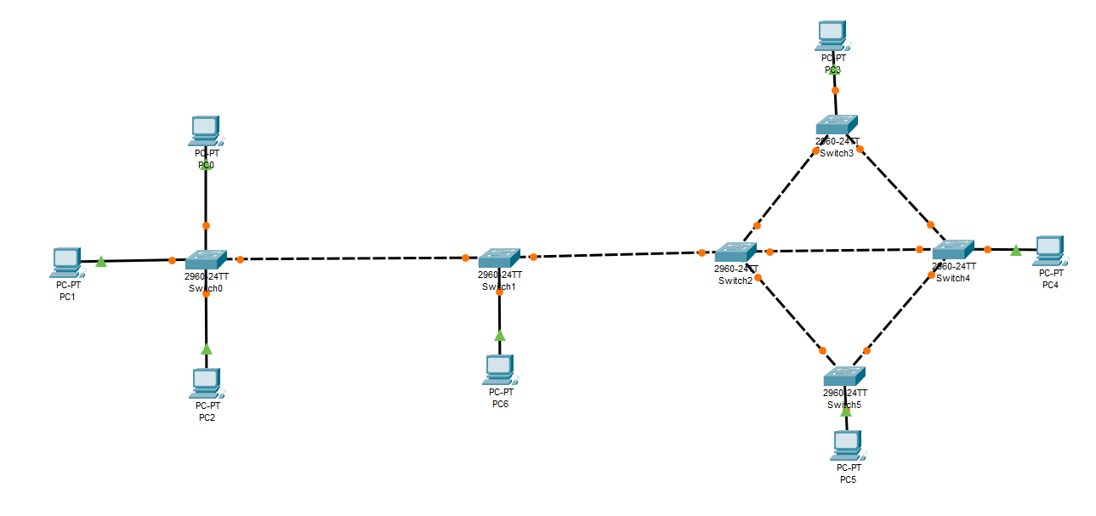
Observation & Learning
The experiment revealed that the star topology is the most efficient in a LAN environment due to its centralized hub, ease of troubleshooting, and reduced risk of complete network failure. The hybrid topology provides flexibility, but proper planning and management are vital.
Understanding network requirements before selecting a topology is crucial, and network simulations play a key role in evaluating and optimizing different configurations. Continual evaluation ensures an optimal, reliable network.
Conclusion
In this experiment, we explored different networking topologies, considering their advantages and limitations. Bus topology is cost-effective but prone to collisions, while star topology is easy to troubleshoot but reliant on a central hub. Mesh topology offers fault tolerance, but complexity and cost are concerns. Hybrid topology allows flexibility by combining strengths.
Questions
- Which is the most efficient topology in LAN environment and Why?
In a LAN (Local Area Network) environment, the most efficient topology is the Star Topology. It offers several advantages that make it well-suited for LANs. Each device connects directly to a central hub or switch, allowing easy management and troubleshooting. Data transmission is directed through the hub, reducing the likelihood of collisions. Additionally, if a single connection fails, only that particular device is affected, leaving the rest of the network operational.

- How we can test the connectivity between the terminals?
Connectivity between terminals can be tested using various methods:
- Ping Test: This test sends an ICMP (Internet Control Message Protocol) echo request from one terminal to another and checks for a response, verifying the connectivity and latency between the devices.
- Traceroute: Traceroute tracks the path data packets take from the source terminal to the destination, helping identify any network bottlenecks or connectivity issues.
- Scanning: Port scanning checks which network ports are open on a terminal, ensuring specific services or applications are reachable.

- What are the two categories of cable? In what type of connection, they are user?
The two categories of cables commonly used in networking are:
- Twisted Pair Cable: Twisted pair cables are of two types: Unshielded Twisted Pair (UTP) and Shielded Twisted Pair (STP). UTP cables are commonly used in LAN environments due to their cost-effectiveness and ease of installation. They are widely used for Ethernet connections in offices, homes, and data centres. STP cables offer better protection against electromagnetic interference and are used in environments with high levels of electrical noise.
- Fiber Optic Cable: Fiber optic cables use light pulses to transmit data, offering high bandwidth and immunity to electromagnetic interference. They are used for long-distance connections, high-speed data transfer, and in environments where electrical interference is a concern, such as in data centres and telecommunications networks.

